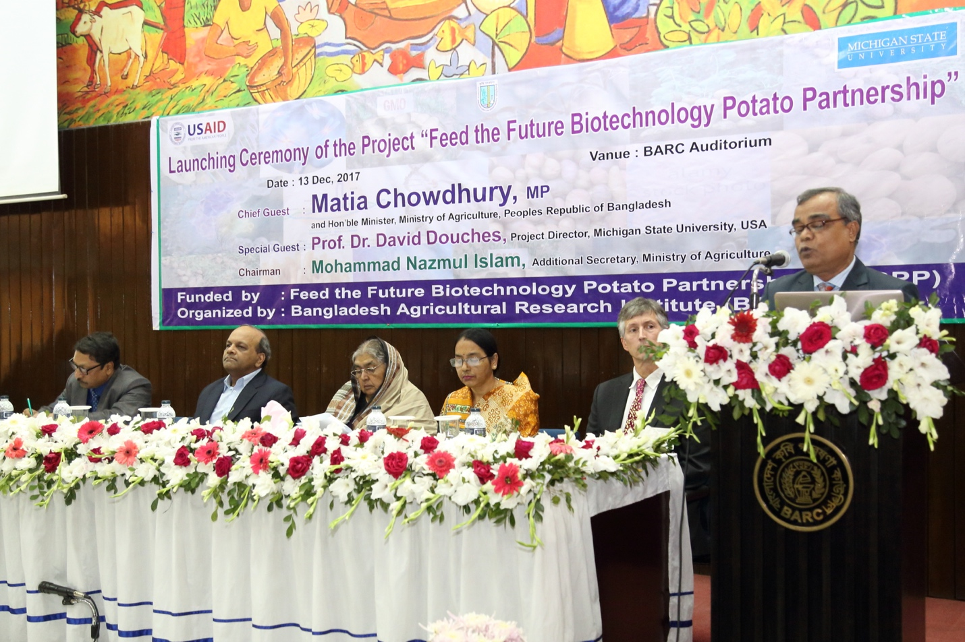
Feed the Future Biotechnology Potato Partnership Launches 3R-Gene Late Blight Resistant Potato in Bangladesh
Dr. Tapan Kumar Paul, Director, Tuber Crops Research Centre, Bangladesh Agricultural Research Institute, addresses the audience at the Feed the Future Biotechnology Potato Partnership launch ceremony.

On December 13, the Bangladesh Agricultural Research Council (BARC) announced the launch of the Feed the Future Biotechnology Potato Partnership during a ceremony in Dhaka. Minister of Agriculture, Matia Chowdhury, attended as the Chief Guest.

Smallholder farmers in Bangladesh are fighting an uphill battle against Late Blight disease. This season a large percentage of crops in the northern part of the country are experiencing heavy losses. Advances in Late Blight resistant biotech potatoes are offering new hope to these farmers.

Dr. Abul Kalam Azad, Director General of Bangladesh Agricultural Research Institute that serves as the project implementing partner addressed the audience saying, “The launch of the 3R-gene potato variety would save almost 25-28% production cost which is being spent by the farmers for protecting the potato crop from the devastating late blight fungal disease.” This savings comes primarily from the reduced need to spray costly fungicides.

Agriculture Minister Chowdhury told the group that in addition to the farmers spending large amounts of money to combat late blight, “the fungicides cause air and environment pollution and increase risk to farmers health. But the GM potato could be the ultimate solution of these health hazards.”

The Feed the Future Biotechnology Potato Partnership, an USAID funded project, is managed by Michigan State University, along with partners the University of Minnesota, University of Idaho and Idaho-based J.R. Simplot Company. The project also consists of two in-country institutional partnerships, one in Bangladesh and one in Indonesia. The Partnership will develop and bring to market a three R (resistance)-gene potato containing the Rpi-blb2, the Rpi-vnt1, and the Rpi-mcq1 genes. In addition, the Feed the Future Biotechnology Potato Partnership will conduct collaborative research on an USAID funded International Potato Center’s three gene Late Blight resistant (LBR) potato containing the RB, the Rpi-blb2, and the Rpi-vnt1 genes.
The project’s social impact goals are to increase partner countries food security, reduce malnutrition and improve health, reduce the use of harmful fungicides, reduce pre- and post-harvest losses and improve the social and economic standing of small-holder farmers. In addition, the project works to develop institutional capacity in partner institutions and their respective governments, develop biosafety operating procedures and stewardship, meet regulatory requirements to ensure safety for human health and the environment, and communicate to the public and stakeholders the benefits of the late blight resistant potato.

